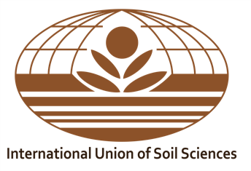
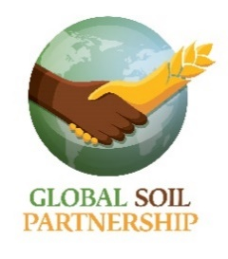
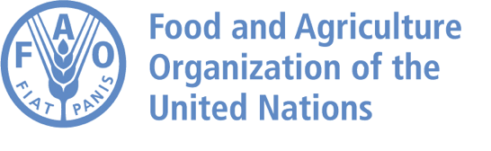

IUSS – FAO – GSP
Booklet contest for children on Soil Biodiversity

Plants nurture a whole world of creatures in the soil, which, in return, feed and protect biodiversity below and above-ground. This diverse community of living organisms keeps the soil healthy and fertile. This vast world determines the main biogeochemical processes that make life possible on Earth. Soil biodiversity plays a vital role in sustaining human welfare, ensuring future agricultural productivity and environmental sustainability. But soil biodiversity loss puts our soils and productive lands at risk.

In order to involve soil scientists, research institutions, soil science societies, academia, colleges and universities, designers, photographers, and creatives people from around the world in efforts to educate and raise awareness on soils among the future citizens of the world, the joint International Union of Soil Sciences (IUSS) - FAO’s Global Soil Partnership (GSP) contest will be launched. This is also the objective of the educational project “THE IUSS GOES TO THE SCHOOL”, which focuses on the idea of putting forward the soil and encouraging children’s interest in it. The preparation of youth-friendly educational programmes and materials is a shared responsibility and a priority task for IUSS and FAO’s GSP.

In the framework of World Soil Day (WSD) 2020, FAO, IUSS and GSP are therefore launching a scientific booklet contest for children on Soil Biodiversity with the motto "Keep soil alive, protect soil biodiversity". This joint activity will be promoted in a coordinated way on digital and social media platforms. The objectives of the contest are to: (1) Promote scientific knowledge and give visibility to the importance of soil biodiversity; (2) Raise awareness of the urgency of protecting soil biodiversity; (3) Stimulate educational activities, engagement and participation of young people and schools in soil science.
PARTICIPATION RULES
I. PARTICIPANTS

FAO, IUSS and GSP invite all those interested in soil and biodiversity - soil scientists, researchers, professors, teachers, classrooms, individual students, soil practitioners, designers, photographers or experts from any professional background - to submit their freestyle booklet proposal based on the WSD 2020 motto: "Keep soil alive, protect soil biodiversity".
Each author and/or group of authors can only submit one entry. The booklet must be the original work of the participant/s and unpublished.
All participants are encouraged to learn more about World Soil Day and to consult the European Commission Joint Research Center’s Global Soil Biodiversity Atlas.

2. SUBJECT

Participants should develop short scientific texts, facts (with scientific references) and images/designed illustrations/hand drawings to illustrate scientific knowledge on soil biodiversity for a young audience. The aim is to educate and highlight the risks associated with soil biodiversity loss, under the WSD 2020 motto "Keep soil alive, protect soil biodiversity".
The ideas and proposals should represent the vital role that soil and biodiversity play in sustaining human welfare, ensuring future agricultural productivity and environmental sustainability.

3. SUBMISSIONS AND REQUIREMENTS

The booklet is intended for children between 6 and 11 years old. The works will only be accepted in English and can be in color or black and white, and in free genre literary (i.e. scientific literature for children, storyboards, comic strips, poetry, activity booklets, pop-up booklets, foldables). All booklets must include the motto "Keep soil alive, protect soil biodiversity". The booklet of each finalists will be translated in all FAO languages and will include the co-organizers logo (IUSS, FAO, GSP, World Soil Day, International Decade of Soils (IDS) 2015 – 2024, and “THE IUSS GOES TO THE SCHOOL” with a short description of the joint initiative.

To guarantee anonymity and therefore fairness during the evaluation process, interested parties should not put their name or that of their institution on the booklet. A REGISTRATION NUMBER will be assigned to the authors upon reception.
- Booklets must be submitted in PDF format with images in high resolution (min 600 dpi).
- The booklet should be a maximum of 16 pages in length, including: (1) Cover indicating the Title; (2) Introduction and Content (freestyle); (3) Back cover. Given the fact that the booklet is intended for children it is advisable to use visuals and do not exceed 2 000 – 3 000 words in text length for the entire booklet.
- It is suggested to work on A paper format (suggested A4 - vertical or landscape) and address the topic in an interdisciplinary way.

Submissions should be sent by 10 November 2020 through any free file transfer service/platform (i.e. Google drive, Share drive, WeTransfer, Dropbox) to iuss@umweltbundesamt.at and World-Soil-Day@fao.org.

In the submission email, author(s) must fill out and submit the mandatory Registration form

4. DEADLINE

The deadline for submission is 10 November 2020.

5. AWARDS
The winner will receive a cash prize of 1 000 USD, second and third prize will receive a cash prize of 500 USD and 250 USD respectively from IUSS and FAO’s GSP. Shortlisted participants will receive publications on soils, a certificate of participation, a mention on the websites (iuss.org and fao.org), and soil gadgets. The best scientific booklets will be showcased on IUSS and FAO’s GSP digital and social media platforms. The winners will be announced on World Soil Day, 5 December 2020.

6. EVALUATION

The IUSS and FAO’s GSP Selection Committee will evaluate all booklet submissions "Keep soil alive, protect soil biodiversity" and the final decisions will be announced by the IUSS President and the FAO’s GSP Secretary on the IUSS and FAO websites. The decision will be final.

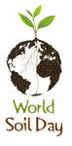

Rome, Italy, August 2020 and Austria, Vienna, August 2020
